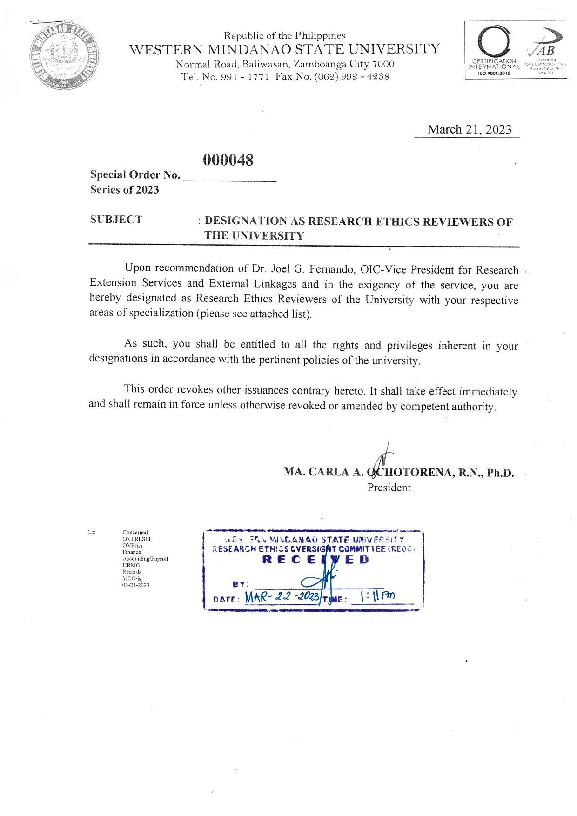

|  |  |  |  |
| --- | --- | --- | --- |
| **WMSU REOC Members** | | | |
| **Designation** | **Name** | | **Field of Specialization** |
| REOC Chair | **Dr. Analyn D. Saavedra** | | Language Teaching, Law |
| REOC Vice Chair | **Dr. Rica Rose May A. Rubio** | | Nursing Supervision and Administration, Medical - Surgical Nursing, Nursing Research, Transcultural Nursing |
| REOC Secretary | **Ms. Jehan L. Ibrahim** | | Political Science |
|  |  | |  |
| **Institutionally Funded Level** | | | |
| Panel Chair | **Dr. Annaliza Rosario P. Dy** | | Psychology |
| Regular Member | **Dr. Melbert C. Sepe** | | Biology |
|  | **Dr. Rica Rose May A. Rubio** | |  |
| Non-Scientific Member | **Mr. Bryan B. Marcial** | | Environmental Science and Technology |
| Non-Affiliated Member | **Dr. Judith Maghanoy** | |  |
| Panel Secretary | **Ms. Jehan L. Ibrahim** | | Political Science |
| Alternate Member | **Dr. Cheryl P. Barredo** | | Filipino |
|  |  | |  |
| **Graduate School Level** | | | |
| *Panel 1* |  | |  |
| Panel Chair | **Dr. Iana Rene C. Estandian** | | SPED, Educational Administration |
| Regular Member | **Dr. Paksah B. Manga** | | Gerontology, Medical-Surgical Nursing, Emergency Disaster |
|  | **Dr. Almudi G. Lukman** | | Environmental Planning and Management |
| Non-Scientific Member | **Ms. Ferduasia Salem** | |  |
| Non-Affiliated Member | **Dr. Roberto Eyo** | |  |
| Panel Secretary | **Mr. Joylito Lahoylahoy** | | English |
| Alternate Member | **Ms. Magnolia T. Grefalde** | | Psychology |
|  |  | |  |
| *Panel 2* |  | |  |
| Panel Chair | **Dr. Dulce Amor P. Matondo** | | Biology (Ph.D.)/Health |
| Regular Member | **Dr. Janet Deleňa** | | Economics |
|  | **Mr. Roel P. Borja** | | History |
| Non-Scientific Member | **Ms. Jovelyn I. Legaspi** | | Education (General Science, MST Biology) |
| Non-Affiliated Member | **Dr. Alexander Ibni** | |  |
| Panel Secretary | **Mr. William Deyne C. Alejandro** | | Accountancy |
| Alternate Member | **Ms. Angelyn B. Sanchez** | | Statistics (MS Statistics) |
|  |  | |  |
| **Undergraduate School Level** | | | |
| *Panel 1* |  |  | |
| Panel Chair | **Mr. Michel Vincent S. Calantas** | Psychiatric Nursing, Community Nursing | |
| Regular Member | **Mr. Rey Ralph H. Virtucio** | Physics | |
|  | **Ms. Nur-Fatha A. Alpha** | Research, First Aid, Sports Science | |
| Non-Scientific Member | **Ms. Mary Anthonette G. Del Rosario** | Nursing | |
| Non-Affiliated Member | **Ms. Roselyn B. Delos Reyes** |  | |
| Panel Secretary | **Ms. Kimberly Joy R. Kilat** | Mass Communication | |
| Alternate Member | **Mr. Munib A. Kahal** | MSW major CO, Peace Education, Rural and Urban Planning | |
|  |  |  | |
| *Panel 2* |  |  | |
| Panel Chair | **Mr. Ryan Joseph M. Dela Torre** | Dactyloscopy, Forensic Photography | |
| Regular Member | **Mr. Ramfred T. Cresmundo** | Nutrition and Dietetics | |
|  | **Ms. Jay Ann T, Dagalea** | Environmental Science and Technology | |
| Non-Scientific Member | **Ms. Munaira B. Villagracia** | Asian Studies | |
| Non-Affiliated Member | **Ms. Lobella D. Collago** |  | |
| Panel Secretary | **Ms. Roselyn C. Espinosa** | Filipino | |
| Alternate Member | **Mr. Jason T. Francisco** | Chemistry | |
|  |  |  | |
| *Panel 3* |  |  | |
| Panel Chair | **Mr. Ryan V. Tandoy** | MSW Major in CO, Teaching major subject in BSCD | |
| Regular Member | **Engr. Ivy L. Francisco** | Industrial Engineering | |
|  | **Ms. Sitti Rasma I. Jailula** | Forest Resource Management | |
| Non-Scientific Member | **Ms. Cherry L. Ladja** | Masters for ASEAN Studies, Teaching major subject in BSCD | |
| Non-Affiliated Member | **Ms. Maisora T. Tahil** |  | |
| Panel Secretary | **Mr. Henry M. Peñales** | Economics and Political Science | |
| Alternate Member | **Ms. Rebecca T. Valerio** | Issue base organizing, Community Development Driven Projects, MSW - Community Organizing major | |
|  |  |  | |
| Independent Consultants | **Atty. Dioscoro Sale** |  | |
|  | **Dr. Maria Gabriela D. Gonzales** | Internal Medicine, Gastroenterology | |
|  | **Mr. Mark L. Flores** | ICT, Data Privacy | |
|  | **Dr. Jocelyn T. Gaas** | Forensic Social Work, Social Welfare Administration, Child Welfare, Human Rights Advocacy, Educational Administration | |
|  | **Atty. Jules Christian D. Marcos** |  | |